# TRINITY METHODIST CHURCH, HARROGATE

A crèche is available for any children who wish to join them during the service.

[www.trinityharrogate.org.uk](http://www.trinityharrogate.org.uk)

**SUNDAY 25th NOVEMBER 2018**

09:00am Holy Communion led by Rev B Clowes

10:30am All Age Worship led by Rev P Whittaker

*Stewards*: Anthea Shenton & Toby and Olivia

*Readers:* Derek Harper & Don Rolls

*Organist:* Church Band *Flowers*: - Freda Fretwell

**TUESDAY 27th NOVEMBER 2018**

12 noon Luncheon Club

7:15pm Steel band

**FRIDAY 30th NOVEMBER 2018**

10:00am Trinity Tots

**SATURDAY 1st DECEMBER 2018**

10:00am Who Let the Dads Out?

**SUNDAY 2nd DECEMBER 2018**

10:30am Holy Communion led by Rev B Clowes

*Stewards*: Sue Covill & Carol Allan

*Readers:* Carol Allan & Doreen Swain

*Organist:* Judith Yates *Flowers*: - Advent

2:30pm Rev B Clowes

**TRINITY NOTICES –** Please let Tracey have any items for Sunday 2nd December by Tuesday 27th November. She can be contacted on **** or by e-mail at ****@talktalk.net *Please note:* notices are on the website each week. [www.trinityharrogate.org.uk](http://www.trinityharrogate.org.uk) Please email with amends or additions. ***TRINITY* IS ON FACEBOOK** Search for Trinity Methodist Church, Harrogate.

**A Golden Thank You -** Elaine has been blown over by all the kind wishes, cards and especially the wonderful flowers given to her and her husband on the occasion of their Golden Wedding. Thank you so very much.

**MWiB** at Wesley – 26 November @ 2:00pm – Speaker John Shackleton

**MWiB Christmas Lunch** at Ascot House on 28th November.

**TRINITY TIMES** contributions for the December issue should be with Muriel Riley by Sunday 1st December.

**October Collections**   
w/c 7 October £241.45; w/c 14 October £347.16; w/c 21 October £312.88; w/c 28 October £313.20. Total including bank transfers £1,970  
Total to break even on operational budget £2,820

**PRAYER TIME** - each week a small group of people faithfully pray for the church, the preacher, the service and more at 10.15am in one of the side rooms for 5-10 minutes. It would be wonderful if more people came to pray. There is no compulsion to pray out loud but a church that prays together is a church that grows. Do think about joining this special ministry.

**EARLY COMMUNION** - Every month on the last Sunday of the month there is a small group who meet for a short, reflective communion service at 9am. All are welcome to join us. From 30th September, we're going to trial doing this in one of the side rooms and follow it up with a brew and pastries. Do consider coming and spending 30 minutes in the peace and tranquillity of God's house.

**CHURCH COUNCIL MINUTES & Privacy Notice** – For your information a copy of the Church Council Minutes from the 18th October 2018 meeting are now available for all to read along with a copy of the Managing Trustees’ Privacy Notice. These can be found pinned to the Church Hall noticeboard.

**HOUSE FELLOWSHIP GROUP** – Next one on ***19th December*** *at 7.45pm* 50 Bogs Lane, Harrogate, HG1 4EB. Future ones 23rd January; 20th February; 20th March; 10th April; 22nd May; 19th June and 17th July.

**CIRCUIT TREASURER REQUIRED** Our present Circuit Treasurer is due to retire in March 2019 having been in this post since 2008. We are, therefore, looking for a replacement treasurer. This will involve someone who has financial qualifications and is computer literate. Full training will be given. This is an essential voluntary role within the Circuit. For full details please contact Peter Gambles – 01423 870700 – email: [petergambles76@gmail.com](mailto:petergambles76@gmail.com)

**Preparation for the forthcoming music presentation, 'Song of Christmas' on 9th December 2018** Mike Butterfield, the composer, from Pannal chapel is asking for any willing 'Shepherd Singers' from Trinity to help augment those singing in this production at Trinity on 9th December. He is hoping to hold rehearsals at Trinity over the next few weeks so that everyone can learn the songs confidently. It would be really good if we could have some volunteers to support this joint venture with our friends at Pannal. If you are willing to help please have a word with one of the Stewards or Don Rolls. Once the rehearsal times have been determined, we will let you know when they are to be held.

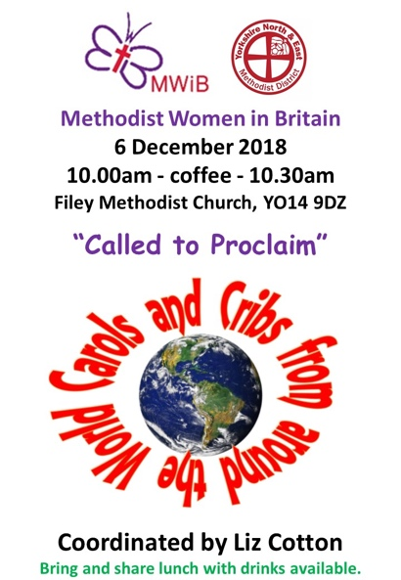**RED BOX PROJECT**: We have become a Red Box donation point. According to their website The Red Box Project is "an initiative that quietly ensures that no young woman misses out on her education because of her period.   
On 2nd December 2018, Trinity will be holding a **CONFIRMATION AND MEMBERSHIP SERVICE** as part of the morning worship. If are not confirmed and would like to become a member of the church, please see Ben for more details. Provisional dates for confirmation classes are: 6pm-7pm on Tuesday 18th September; 23rd October, 20th November.

**PANNAL CHURCH** are performing ‘Song for Christmas’ at Trinity on **9th December** at 7pm. They would welcome anyone who wishes to take part, adults or children. this is a lovely piece and I having seen it last year I can guarantee that you will love it. If you feel that you would like to be part of this production please let Mary Briggs or one of the other stewards know.

**Worship: Leading & Preaching** An Open Forum withBob Bartindale**,** Connexional Officer for Worship & Local Preachers on Thursday 17 January 2019 7.00pm – 9.00pm at The Bar Convent, York (Blossom Street, YO24 1AQ)

Minister – Rev Ben Clowes – Tel: 870977 E-mail: [revbclowes@gmail.com](mailto:revbclowes@gmail.com)

*Children’s & Families Worker* : Jaynie Kendall (from 1st September)