TRINITY METHODIST CHURCH, HARROGATE
A crèche is available for any children who wish to join them during the service.
www.trinityharrogate.org.uk
SUNDAY 31st MARCH 2019
09:00am Rev B Clowes
10:30am Rev B Clowes
Stewards: Sue Covill & Toby/Lucy B
Readers: Toby Crisell & Lucy Morris
Organist: Church Band Flowers: - Elsie Boston

TUESDAY 2nd APRIL 2019
12 noon Luncheon Club
7:15pm Steel band

FRIDAY 5th APRIL 2019
10:00am Trinity Tots

SUNDAY 7th APRIL 2019
10:30am Rev C Lake
Stewards: Lynda Dale & Margaret Rodham
Readers: Anthea Shenton & Mary Briggs
Organist: Jean Clay Flowers: - Lorna Sutch

TRINITY NOTICES – Please let Tracey have any items for Sunday 7th April by Tuesday 2nd. She can be contacted on **** or by e-mail at ****@talktalk.net Please note: notices are on the website each week. www.trinityharrogate.org.uk Please email with amends or additions. TRINITY IS ON FACEBOOK Search for Trinity Methodist Church, Harrogate.
PRAYER TIME - each week a small group of people faithfully pray for the church, the preacher, the service and more at 10.15am in one of the side rooms for 5-10 minutes.
EARLY COMMUNION - Every month on the last Sunday of the month there is a small group who meet for a short, reflective communion service at 9am. All are welcome to join us.
Church AGM – On 31st March 2019 the Church AGM is due to take place. This year things will be done slightly differently in that the meeting is going to take place during the Sunday Morning Service which will be a café church. Coffee will be served at the start and, as this particular Sunday is Mothering Sunday and Trinity’s 140th Anniversary, the service will last approximately an hour and a half. There will be some colouring activities and toys available for younger children, supervised by their parents, during the part of the service that includes the AGM. Adele Goodall, Church Secretary.
FUNERAL Val Marshall, wife of supernumerary minister in the Tadcaster Circuit, Ken Marshall, passed away on Monday. Ken has served in several stations throughout the district and will be known to many. There will be a thanksgiving service on Thursday April 4 at 11.00 am at Church Fenton Methodist Church, followed by refreshments in the village hall. Donations on the day will go to Choma Orphans (Zambia).
HOUSE FELLOWSHIP GROUP – Next one on 10th April at 7.45pm 50 Bogs Lane, Harrogate, HG1 4EB. Future ones 22nd May; 19th June and 17th July.
COFFEE MORNING on 13th April including cake stall and bric a brac sale to raise money for Action for Children which is the children’s charity of the Methodist Church. Please put it in your diary.
Invitation to your Church – The People’s Passion – Sunday 14th April (Palm Sunday) at 3pm.
A powerful piece of theatre and worship. From the roaring crowd at the entry into Jerusalem to the moving drama of the crucifixion, a chorus of voices tell the Easter story. There’s a part for everyone to play and no rehearsal needed. Suitable for adults and children so long as they can read, this is led by the renowned Riding Lights Theatre Company from York, who will be our resident drama team for the event. We are offering free tickets for the afternoon as a way of marking Palm Sunday together, available from 1 March on the booking site at http://www.springharvest.org/harrogate

MHA Berwick Grange Spring Fling
Saturday 6 April 2.30 – 4pm
Tickets on the door £3
Include tea/coffee and hot cross buns
Easter egg tombola
Donations of Easter eggs welcomed please!

Minister – Rev Ben Clowes – Tel: 870977 E-mail: revbclowes@gmail.com
Children’s & Families Worker : Jaynie Kendall

Starbeck Methodist Church, the last concert of the winter season.
Saturday 13th April, 7.30pm; Harrogate Band in Concert ; Admission £8.00, children free.
For further information see notice board in entrance.
The Sound of Silence
A district day to explore and reflect on the Cistercian tradition and the life and writings of Aelred, abbot of Rievaulx (1147-1167)
Saturday July 20th 2019 10 am – 4 pm
based at the Methodist Chapel in Rievaulx with admission to the Abbey.

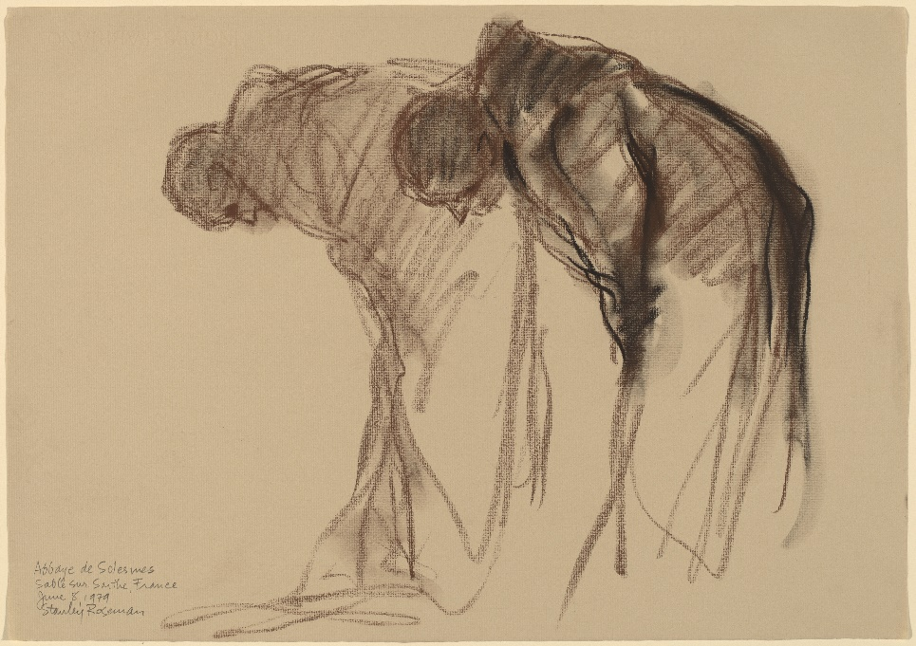
Abbaye de Solesmes. Stanley Rosman Used by permission
The day will be led by the Revd. Dr. Kenneth Carveley who is a church historian and liturgist with the Mirfield Liturgical Institute and a Cistercian scholar who has researched and taught the Cistercian tradition over many years.
Cost £5 per person. Parking: There is limited parking at the chapel, and further parking at the Abbey. Lunch : bring your own picnic lunch, tea and coffee will be available, or use the café at the Abbey.
Book with Siân Henderson at the Yorkshire North & East District Office, 28 The Green, Acomb, York, YO26 5LR. admin@yorkshirenemethodist.org. 01904 786275

Coffee Morning Saturday 27th April During the coffee morning we will be showing the recording of the 100Th anniversary ‘’Songs of Praise’’ service led by our then minister the Rev Leslie Goy. The showing will start at 10.30 a.m. until 11.30 a.m. and coffee will be served from 10.00 a.m. as usual.
Hampsthwaite are replacing their chairs and would like to offer theirs to anyone who can use them, churches, community groups, individuals. Grace Cauldwell, Methodist Minister- Nidd Valley Circuit
01423 562542; 07341 960506

SAVE THE DATE – The Call. On Saturday 6th July 2019, the Nidd Valley Circuit will host The Call tour at Wesley Centre.
An evening of music and celebration led by musician, composer and worship leader, Matt Beckingham
Please put this date in your diary. More details to follow.....
FLOURISH You can now make bookings for Flourish tickets here: (free) https://www.eventbrite.co.uk/e/flourish-the-yorkshire-north-east-district-weekend-tickets-55019533907?aff=eac2 Fri 18 Oct 19:30 to Sun 20 Oct 13:00 at Scarborough Spa YO11 2HD
Minister – Rev Ben Clowes – Tel: 870977 E-mail: revbclowes@gmail.com
Children’s & Families Worker : Jaynie Kendall

